Cooperative Extension
Service
Trigg County
P.O. Box 271
Cadiz, KY 42211-0271
(270) 522-3269
Fax: (270) 522-9192
www.ca.uky.edu/ces

Greetings,
Trigg County Extension Homemaker Newsletter
Fall 2023

I am honored and blessed to be the new
Family Consumer Science Agent for Trigg County. I look forward to serving you and our lovely community. This is going to be a great journey!

A bit about myself: I have been a teacher for
28 years. I earned a Master’s in Education
from Murray State University, and I am a member of Phi Kappa Phi. My husband and
I have a blended family of 5 grown children which include 3 daughters, 2 sons, and a
sweet 2 ½ year old grandson. A few of my favorite things are cooking, crafting, singing, reading, family game nights, and our adorable Cavapoo, Willow. I look forward to meeting you!

Blessings,
Teresa Garcia

“Isn’t she just the cutest?”

Upcoming Homemaker Events:

Trigg County Homemakers Annual Meeting
Wednesday, Sept. 20th at 4:00 pm.
Senior Citizens Center
127 Joy Lane
Cadiz, Ky
Potluck Meal:
Salad, Sandwiches, & Desserts

Pennyrile Area Homemakers Meeting

Ham Festival
October 13 & 14, 2023

Bring entries to:
Cadiz Baptist Church Annex
ON THURS. OCT. 12th
Between 9:00 am and 12:00 pm
See Information about Ham Festival
Entry Classes and Numbers attached.

FCS Events:

Diabetes Education Classes
October 26th and 30th
1:00 pm to 5:00 pm
Trigg County Extension Office

October 26: What is Diabetes, How to treat high and low blood sugars, Long term complications, Taking care of your feet, teeth, & skin, Monitoring & Management, Being active, Goal setting.

October 30: Medications, What to do on sick days, Healthy eating, Coping with diabetes, Goal setting.

Please register by October 24th
(270)-522-8182 ext. 212

Presented by Kelly Dawes & Teresa Garcia

One of my favorite stories…..

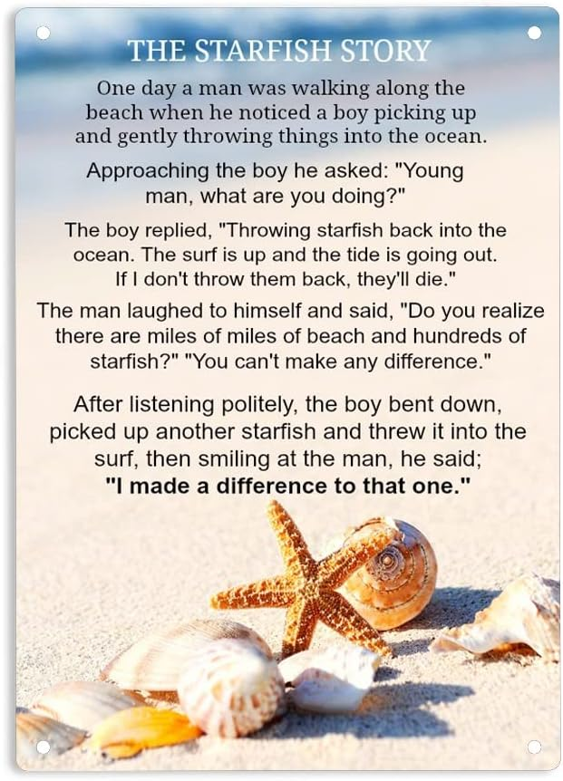

A favorite Quote:

“No one cares how much you know until they know how much you care.”
~President Theodore Roosevelt

